Physiological Response of Rice Plant (Oryza sativa L.) 'Segreng' to Biogas Sludge at Wukirsari Village, Cangkringan, Sleman

Dwi Umi Siswanti^{1*}, Sudjino¹, Nindy Senissia Asri¹, Mifta Arlinda¹, Arianda Poetri Shofia Rochman¹, Akrima Syahidah¹.
- Faculty of Biology, Universitas Gadjah Mada
*) dwiumi@ugm.ac.id

Abstract. Wukirsari Village, Cangkringan District belong the part of Merapi Mountain’s slopes which located between the Gendol River and Yellow River. Nowadays, we faced the problem of anorganic fertilizer overused such as Urea, ZA, TSP/SP-36 and KCl in agriculture land. The effort to return the soil organic compound can be done by added some organic compounds or microbial bio organic fertiziler. Sludge is fermented biodigester yield and it has lost its gas. The aim of this research was to understand the physiological respons and optimum dose of biogas as planting medium to ‘Segreng’ Rice planted in the rice field of Wukirsari Village, Cangkringan District, Sleman Regency. This research was done on greenhouse scale and rice field scale. The treatment given on 0; 1; 1,5; 2 and 2,5 liters per 100 m² of rice field areas, and given on 0; 4; 8; 12; and 24 ml per 5 kgs soil on polybags. Data were taken in three repetitions. The vegetative growth parameters included plant height, number of leaves, number of seedlings and chlorophyll content, while generative growth parameters measured included NRA levels, dried biomass including crown/stem, roots, filled grains, empty grains, and total weight and number of filled grains, empty rains, and the number of panicles. The result were tested with ONE WAY ANOVA (Analysis of Variance) with SPSS version 19 for Windows and followed by Duncan's Multiple Range Test with 95% significance level (α = 0.05). Generally, the result showed that biogas sludge can increase the vegetative and generative growth of rice plant ‘Segreng’ on polybag scale and rice field scale. The rice plant on polybag with 4 ml biogas sludge was significantly different on the vegetative growth and chlorophyll content, while the rice plant on polybag with 8 ml biogas sludge was significantly different on the generative growth and NRA levels.

Keywords: Physiological Response, Sludge, Biogas, ‘Segreng’, Wukirsari

INTRODUCTION

Background

Rice (Oryza sativa L.) is Indonesian main food and strategic commodity. However, rice production in Indonesia has not been able to meet the population demands (Alavan et al., 2015: 61-68). In Yogyakarta, the rice demand continues to increase because the growth of population is not balanced with agricultural area expansion and rice quality improvement. This in turn led to a decrease in rice production.
Wukirsari Village, Cangkringan District belongs to Sleman Regency which is the supplier of rice in the Special Region of Yogyakarta. The area of this village is 1,456 ha. Topographically, the village is located at an altitude of 450 to 600 m above sea level, with an average rainfall of 22 mm / year. The average temperature per year is 21-31ºC. Wukirsari village is a suitable area for agriculture. Wukirsari village is located between the Gendol River in the east and the Yellow River to the west (RPJM Desa Wukirsari, 2015; Siswanti, 2015).
Rice production in Yogyakarta has decreased from 721,674 tons in 2013 to 713,800 tons in 2014 (BPS Daerah Istimewa Yogyakarta, 2015). The productivity decrease becomes a serious obstacle faced by the agricultural sector today. One of the impacts is the use of inorganic fertilizers such as Urea, ZA, TSP / SP-36 and KCl (Redono, 2016: 29). The abundance of inorganic materials in the soil reduced the regeneration ability of rice plants (Sudadi & Widada, 2001 in Redono, 2016: 29). According to Siswanti (2015), the agricultural land in Sleman District, including in Wukirsari Village contains high chemicals due to excessive use of chemical fertilizers (500 kg / ha).
Bio organic fertilizers can improve the physical, chemical, and biological properties of the soil that make them quite profitable. One kind of bio organic fertilizers that is expected to contain many nutrients is biogas sludge. Biogas produces liquid solid waste in the form of livestock manure that has lost its gas and is rich in the elements needed by plants such as protein, cellulose, lignin which cannot be replaced by chemical fertilizers (Ginting, 2007).
Until now there has been no research on red rice plant using biogas sludge as fertilizer, therefore, it was not yet known about the effect of biogas sludge as planting medium to vegetative and generative growth, chlorophyll content and NRA content of Segreng rice planted in the rice field of Wukirsari Village, Cangkringan District, Sleman Regency.

Objective
The aim of this research is to understand the effect of biogas sludge as planting medium on the vegetative growth, generative growth, chlorophyll content and the Nitrate Reductase Analysis (NRA) value of ‘Segreng’ rice, and to find out the optimum concentration of biogas sludge on the growth of 'Segreng' rice.

METHODS

Tools and Materials

The tools used in this study were plows, bamboo, 1 liter glass cylinder, thermometer, soil pH tester, luxmeter, tube, spectrophotometer, analytical scale, micropipet, pipette, pump pippet, porcelain pallet, Whatman no.1 filter paper, aluminum foil, cuvette, scissors, oven, 100 ml measuring flask, and dark flakon.
Materials used in this study were Segreng rice seedlings, paddy soil, biogas sludge, polybag, water, 80% acetone, distilled water, salt, phosphate buffer pH 7.5 0.1 M, NaNO₃ 5 M, 0.02% NED, 1% SA in 3 N HCl, aquadest, NaNO₂ 0.6 M, tissue paper, and aluminum foil.

Data Collection

Rice field with an area of 500 m² was divided into five parts/plots so that each plot size was 100 m². Plot 1 (control) was not added with sludge, plot 2 was added with 1 liter of sludge, plot 3 was added with 1.5 liter sludge, plot 4 was added with 2 liter sludge, and plot 5 was added with 2.5 liter sludge.
Meanwhile, on polybag media treatments, preparation of rice field soil was done by measuring the weight until 5 kg, mixed with sludge, then put them in polybags with the diameter of 21 cm. The treatment given on P1 (control) was not added with sludge, P2 ws added with 4 ml sludge, P3 was added with 8 ml sludge, P4 was added with 12 ml sludge, and P5 was added with 24 ml sludge.
Parameters measured on the growth of rice plants include the number of leaves, number of seedlings, plant height, and analysis of chlorophyll content by Spectrophotometric Method (AOAC, 1995). While the parameters measured on the productivity of rice crops include dry weight, number of panicles, the weight of filled and empty grains, the number of filled and empty grains, and NRA value analysis using modified Assay Method (Hartiko, 1983).
The data of vegetative parameter, generative parameter, chlorophyll content and NRA level of the 5 treatments were tested with ONE WAY ANOVA (Analysis of Variance) with SPSS version 19 for Windows and followed by Duncan's Multiple Range Test with 95% significance level (α = 0.05)
Observation and measurement of vegetative parameters were done every week for 9 times of observation, followed by observation and measurement of generative parameters done every week for 5 times of observation. Parameters observed included plant height, number of leaves, number of seedlings, total chlorophyll content, dry biomass weight, crown weight, root weight, filled grains weight, empty grains weight, number of filled grains, number of empty grains, number of panicles, and NRA levels.
The steps taken in this research were land preparation, seed preparation, rice seed planting, parameters measurement and rice plant maintenance. Preparation of land included the process of jacking rice fields with a depth of 20-25 cm and repeated 2 times with 1 week time difference. This was aimed to ensure the soil conditions become poor of nutrients, so that the effect of biogas sludge becomes significant.
In the meantime of waiting the readiness of rice field, preparation of Segreng rice seedlings was done. Segreng variety rice was chosen for this study because it has several benefits including:
1. High yield, i.e. 3-4 ton / ha,
2. The husks contain β-carotene of 488.65 micro g / 100 g,
3. High rice selling value, which is 30% more expensive than ordinary rice,
4. Tolerant to water stress,
5. High protein content of about 7.3%, completed with 4.3% iron and 0.34% vitamin B1 (Kristamtini and Prajitno, 2009).
Rice seeds were first soaked in 3% NaCl solution for 24 hours. This treatment served to separate good quality rice seeds with the bad ones. Good quality rice seeds would sink, while bad seeds would float when soaked in salt solution. Furthermore, good quality rice seeds were dried under sunlight for about 3 days until dry grains were obtained. It aimed to avoid possible contamination of moist rice seeds.
Furthermore, rice seeds were spread in a nursery area of 2x2 m² with inundated soil. In this condition, seeds would experience imbibition, or the process of water seeping into the seeds. Water would activate enzymes that play roles in the germination process. The seeds were grown until 20 days. At this age, the rooting system of the rice seedlings were strong enough and the number of leaves were more than 4, so it could be stated that the rice seedlings were ready to be moved to the rice field.
Prior to the process of moving rice seedlings to the rice field, the land were processed with biogas sludge. Biogas sludge used were 0; 1; 1.5; 2; and 2.5 liters per 100 m² of the rice field and 0 ml; 4 ml; 8 ml; 12 ml and 24 ml per 5 kg of soil on polybags. Data were taken on three repetitions. The vegetative growth parameters included plant height, number of leaves, number of seedlings and chlorophyll content, while generative growth parameters measured included NRA levels, dried biomass including crown/stem, root, filled grains, empty grains, and total weight and number of filled grains, empty rains, and the number of panicles.
The treatment of rice crops included the opening of irrigation flows, weeding and eradicating pests. Measurements of growth parameters were done weekly. The measurement of plant height was done by medline from the base of stem to the highest leaf tip. The number of seedlings is the number of new clumps that appears next to the parent plant. The total number of leaves is the number of leaves of the parent plant and the number of leaves of the seedlings or clumps. The measurement of chlorophyll content was done on the 4th week, the leaf samples used were parent plant leaves, taken ± 5 cm in the middle of the leaf. This was because the section was assumed to be mesophyll tissue where the process of photosynthesis happens, so the chlorophyll content obtained were expected to be more optimum than at the edges.
The measurement of chlorophyll content was done by spectrophotometric method. The principle of the spectrophotometric method is measuring the absorbance value of the solution to a particular wavelength. In this study, the wavelength used were 642,5 nm and 660 nm, because chlorophyll a is able to absorb wavelength of 673 nm, while chlorophyll b is able to absorb wavelength of 455-640 nm.
Meanwhile, NRA test was done when the rice entered the generative stage, marked by busted panicles. The NRA test was performed because the activity of enzyme nitrate reductase could show how much the rate of metabolism in the plant body is increased due to the preparation of building molecules (proteins) to be transported to the grain of rice. Nitrate reductase is the key enzyme that first converts nitrate ions which are absorbed by the roots into nitrites, which are then converted to ammonia. Ammonia will react with glutamine to form amino acid glutamate and form other amino acids. These amino acids are used as cell constituents and transported to the grain. Therefore, according to Alnopri (2004), NRA levels usually show predictions of the productivity of panicle-busted rice.
In the NRA test, the rice leaves used were ‘flag leaves’ or the leaves located just above the grains. The flag leaves are the topmost leaves and the youngest leaves among the other leaves. Young leaves have a higher activity than the old leaves. According to Hartiko (1983), the leaf that has a higher position has a higher nitrate reductase activity than the leaves below it.

Result and discussion

Result
Based on the research, the vegetative growth parameters included plant height, number of leaves, number of seedlings and chlorophyll content, while generative growth parameters measured included NRA levels, dried biomass including crown/stem, root, filled grains, empty grains, and total weight and number of filled grains, empty rains, and the number of panicles, was present below:

- (b)
Figure 1. The average of Plant Height on 9th weeks (a) rice field, (b) polybags
Treatment 1= Control
Treatment 2= 1 liter sludge/100 m² or 4 ml sludge/polybag
Treatment 3= 1,5 liters sludge/100 m² or 8 ml sludge/polybag
Treatment 4= 2 liters sludge/100 m² or 12 ml sludge/polybag
Treatment 5= 2,5 liters sludge/100 m² or 24 ml sludge/polybag

- (b)
Figure 2. The average of Number of Leaves on 9th weeks (a) rice field, (b) polybags
Treatment 1= Control
Treatment 2= 1 liter sludge/100 m² or 4 ml sludge/polybag
Treatment 3= 1,5 liters sludge/100 m² or 8 ml sludge/polybag
Treatment 4= 2 liters sludge/100 m² or 12 ml sludge/polybag
Treatment 5= 2,5 liters sludge/100 m² or 24 ml sludge/polybag

- (b)
Figure 3. The average of Number of Seedling on 9th (a) rice field, (b) polybags
Treatment 1= Control
Treatment 2= 1 liter sludge/100 m² or 4 ml sludge/polybag
Treatment 3= 1,5 liters sludge/100 m² or 8 ml sludge/polybag
Treatment 4= 2 liters sludge/100 m² or 12 ml sludge/polybag
Treatment 5= 2,5 liters sludge/100 m² or 24 ml sludge/polybag

- (b)
Figure 4. The Chlorophyll Content of each treatment on (a) rice field and (b) polybags.
Treatment 1= Control
Treatment 2= 1 liter sludge/100 m² or 4 ml sludge/polybag
Treatment 3= 1,5 liters sludge/100 m² or 8 ml sludge/polybag
Treatment 4= 2 liters sludge/100 m² or 12 ml sludge/polybag
Treatment 5= 2,5 liters sludge/100 m² or 24 ml sludge/polybag

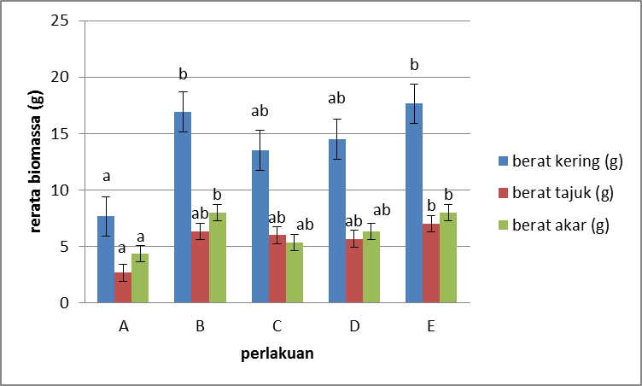
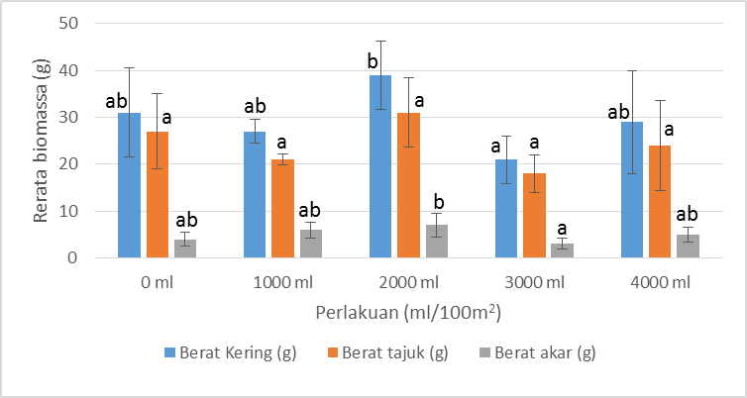
- (b)
Figure 5. The average of dried mass on (a) rice field and (b) polybags
Treatment 1= Control
Treatment 2= 1 liter sludge/100 m² or 4 ml sludge/polybag
Treatment 3= 1,5 liters sludge/100 m² or 8 ml sludge/polybag
Treatment 4= 2 liters sludge/100 m² or 12 ml sludge/polybag
Treatment 5= 2,5 liters sludge/100 m² or 24 ml sludge/polybag

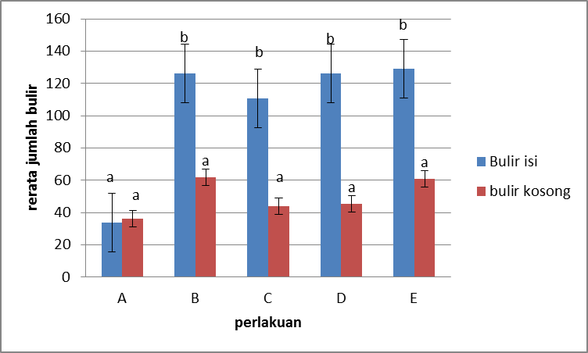
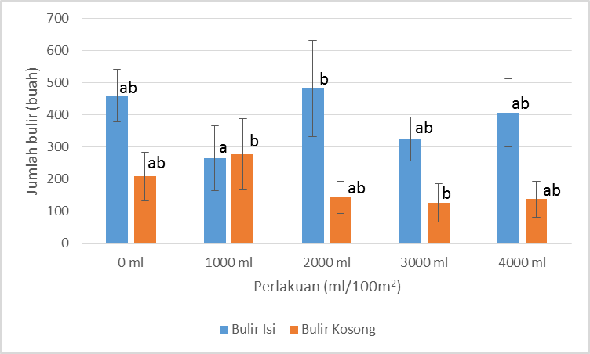
- (b)
Figure 6. The average number of panicles on (a) rice field (b) polybag
Treatment 1= Control
Treatment 2= 1 liter sludge/100 m² or 4 ml sludge/polybag
Treatment 3= 1,5 liters sludge/100 m² or 8 ml sludge/polybag
Treatment 4= 2 liters sludge/100 m² or 12 ml sludge/polybag
Treatment 5= 2,5 liters sludge/100 m² or 24 ml sludge/polybag

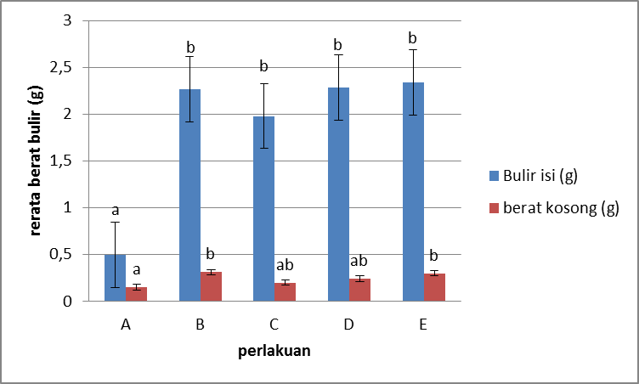
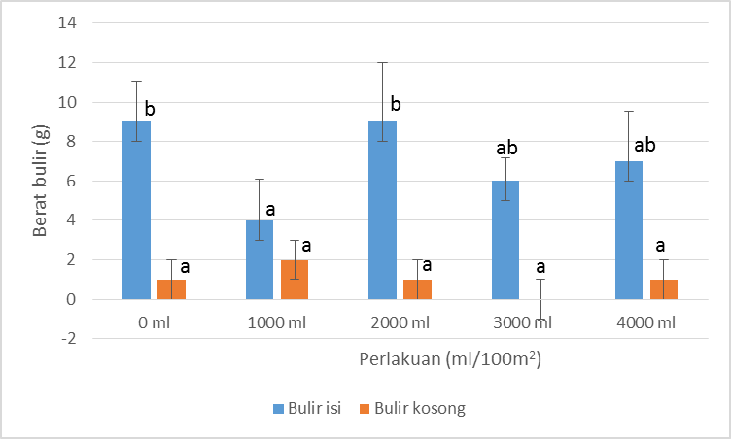

- (b)
Figure 7. The number of grains on (a) rice field and (b) polybags
Treatment 1= Control
Treatment 2= 1 liter sludge/100 m² or 4 ml sludge/polybag
Treatment 3= 1,5 liters sludge/100 m² or 8 ml sludge/polybag
Treatment 4= 2 liters sludge/100 m² or 12 ml sludge/polybag
Treatment 5= 2,5 liters sludge/100 m² or 24 ml sludge/polybag

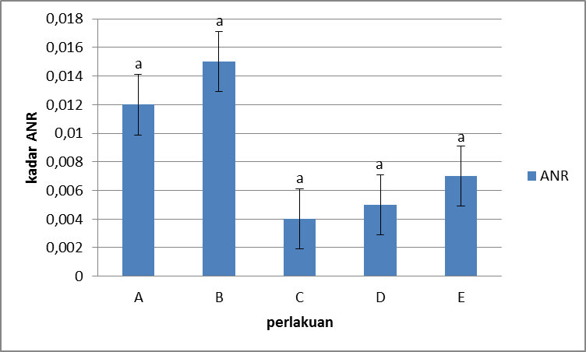
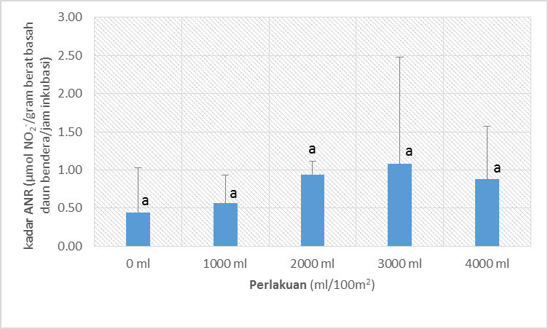
- (b)
Figure 8. NRA levels of sample on (a) rice field and (b) polybags
Treatment 1= Control
Treatment 2= 1 liter sludge/100 m² or 4 ml sludge/polybag
Treatment 3= 1,5 liters sludge/100 m² or 8 ml sludge/polybag
Treatment 4= 2 liters sludge/100 m² or 12 ml sludge/polybag
Treatment 5= 2,5 liters sludge/100 m² or 24 ml sludge/polybag

Discussion

The rice cultivation system conducted in this research is the Legowo Jajar planting system or commonly known as Tajarwo. Tajarwo system is a planting system with spaces between rows : 25 cm, in rows : 12.5 cm, and between legowo / groups of rows : 50 cm. The spacing is arranged by narrowing the distance of the rice inside the row and widening the distance between the rows. Tajarwo's unique principle is the arrangement of rice plants that affects those at the outer sides. Generally, the plants grown at the outer sides provide better growth than plants in the middle because of the reduced inter-row plant competition (Pahruddin et al., 2004). Tajarwo was chosen because it has several advantages, i.e. sunlight can be absorbed by the stem better so that the rate of photosynthesis is higher, fertilization and crop pest control are easier to be done because there is a wide distance (legowo) between rows. In addition, the Tajarwo system can also increase the population of plants per hectare (Pahruddin et al., 2004). A previous research by Anggraini et al. (2013) also shows that the productivity of rice grown by Tajarwo planting system is better than by conventional / tile system. The Tajarwo system has the advantage of having wide open space between two groups of crop rows, increasing the intensity of sunlight entering the clumps, increasing rice yield to 10-15%, facilitating plant maintenance, and reducing the risk of pests and diseases (Abdulrachman et al. 2013).
The height of Segreng rice crops tend to increase every week. The height drop of rice plants with treatment of 24 ml / 5kg at week 4 was possibly due to the pest attack or the torn out leaves at several centimeters from the top. From table 2 on environmental parameters data, it can be seen that there was a considerable decrease in air humidity, it can also indicate a decrease in the height of rice plants. Figure 2 is given to clarify the observations for plant height. Based on the observations, the highest plant height was found in rice plants grown in 4 ml sludge / 5kg of rice field soil. Based on DMRT test (α = 0,05), the effect of biogas sludge dosage on plant height was not significantly different. This can happen if the rice plants have reach the vegetative phase at the 9th week, because according to Vergara (1976), the rice plant at the 4th week until before the 7th week is actively propagating to produce seedlings and after the 7th week, the plant is ready to enter the reproductive phase by initiating the formation of panicles. After going through the planting period, the rice plants at week 7 have entered the reproductive phase. The rice plant has passed through a phase where the cells of active plants divide and enlarge.
Of the five treatments, the best biogas sludge concentration for the vegetative parameters of Segreng rice was P2 (1 L / 100 m²). Based on ANOVA test result, the result of treatment 2 (P2) was significantly different to treatment 5 (P5).
Meanwhile, the number of leaves were obtained on the 9th week. The treatment that gave the highest total number of leaves was treatment 2 (P2) that was 1 L / 100 m² or 100 L / ha. Based on ANOVA test result, it was found that treatment 2 (P2) was significantly different to treatment 5 (P5). This is because at that concentration, the N and Mg content is optimally absorbed by the rice plant for chlorophyll synthesis, to obtain more leaf number than other treatments.
Plant growth is influenced by various factors, both internal factors and external factors. Internal factors derived from the seeds of rice itself (e.g. genetic and seed conditions), while external factors derived from the surrounding environment around the rice which certainly has an influence on rice growth. Each place has a different environment, be it air temperature, water temperature, soil moisture, soil pH, other soil conditions, pests and diseases, and rainfall. The existence of these variations of environmental conditions certainly result in the different growth and development of rice among regions, although given the same treatment.

conclusion and suggestion

Conclusion
The biogas sludge could increase the vegetative and generative growth of ‘Segreng’ rice plant on rice field nor polybags in Wukirsari Village, Cangkringan, Sleman. Based on the DMRT analysis with One Way Anova, the Treatment 2 viz 1 Liter/100 m² or 4 ml/polybag gave the best result on vegetative growth and chlorophyll content of the ‘Segreng’ rice plant. Meanwhile, treatment 3 viz 1,5 liters/100 m² or 8 ml/polybag gave the best result for generative growth and NRA levels of the ‘Segreng’ rice plant.

Suggestion
Based on the research that has been done, there are some suggestions to support the next research of organic farming, such as we need to increase the biogas sludge concentration and need to add the treatment range to get significantly differences by One Way Anova analyze.

REFERENCES
Abdulrachman, S., M. J. Mejaya, N. Agustiani, I. Gunawan, P. Sasmita, A. Guswara. 2013. Legowo Cultivation System. Badan Penelitian dan Pengembangan Pertanian Kementerian Pertanian. Subang. p: 8
Alavan, Ade, Rita Hayat, dan Erita Hayati. 2015. Pengarhun Pemupukan Terhadap Pertumbuhan Beberapa Varietas Padi Gogo (Oryza sativa L.). Jurnal Floratek 10: 61-68.
Badan Pusat Statistik Indonesia. 2016. Rata-rata Konsumsi Per Kapita Seminggu Beberapa Macam Makanan Penting. https://www.bps.go.id/linkTabelStatis/view/id/950. Accessed on 1st April 2016.
Ginting. 2007. Teknologi Pengolahan Limbah Peternakan. Fakultas Pertanian Universitas Sumatra Utara. Medan.
Hartiko, H. 1983. Leaf and root in vivo nitrate reductase activities of coconut (Cocos nucifera L.) cultivars and hybrids. Ph.D Dissertation of University of the Phillipines. Los Banos, p: 1-32
Pahruddin, A., Maripul dan P. Rido. 2004. Cara tanam padi sistem legowo mendukung usaha tani di desa bojong, cikembar sukabumi. Buletin Teknik Pertanian, 9(1): 10-12
Redono, Cucuk. 2016. Respon Petani Terhadap Penggunaan Pupuk Organik Pada Tanaman Padi Sawah di Kelurahan Bokoharjo Kecamatan Prambanan Kabupaten Sleman. Jurnal Agrica Ekstensia. Vol. 10 No.1st, June 2016. p. 29
RPJM Pemerintah Desa Wukirsari. 2014. Rencana Pembangunan Jangka Menengah Desa (RPJMDes) Wukirsari, Cangkringan, Sleman. Unpublished.
Siswanti, D.U. 2015. Pertanian Organik Terpadu Di Desa Wukirsari, Sleman, Yogyakarta Sebagai Usaha Pemulihan Kesuburan Lahan Terimbas Erupsi Merapi 2010 Dan Pencapaian Desa Mandiri Sejahtera. Indonesian Journal of Community Engagement. Vol. 01 No. 01, September 2015.
Steenis, Dr. C.G.G.J van. 1988. FLORA: Untuk Sekolah Indonesia. PT. Pradnya Paramita. Jakarta. p. 127.
Sutejo, M.M. 1995. Pupuk dan Cara Pemupukan. Jakarta: Rineka Cipta.
Suzuki, K, Takesi W and Volum.2001. Concentration and Critalization of Phosphate, Ammonium and Mineral in the Effluent of Biogas Digester in the Mekong Delta. Jerrrean and Contho University Vietnam. Vietnam. p.3

