***High Performance Liquid Chromatography* (HPLC) FOR DETECTION GLUCOSAMINE AND CHONDROITIN SULFATE COMPOUNDS**

**Rakhmiyati1,*, T Widiyani1,2, A Budiharjo1,2**

**1**Department of Bioscience, Graduate Program, Sebelas Maret University. Jl. Ir Sutami No. 36A, Kentingan, Surakarta, 57126, Central Java, Indonesia. Tel./Fax. +62-271-663375, Email: miarakhmiy@gmail.com1

2, 3Department of Biology, Faculty of Mathematics and Natural Sciences, Sebelas Maret University. Jl. Ir Sutami No. 36A, Kentingan, Surakarta, 57126, Central Java, Indonesia. Tel./Fax. +62-271-663375, Email: [tetri_mipa_uns@yahoo.com](mailto:tetri_mipa_uns@yahoo.com)2, [budiharjo_ag@yahoo.com](mailto:budiharjo_ag@yahoo.com)3

Corresponding author*

[miarakhmiy@gmail.com](mailto:miarakhmiy@gmail.com)

Abstract

Glucosamine and chondroitin sulfate are compounds found in shark cartilage (*Carcharhinus sorrah*). The two compounds have many health benefits, that is wound healing and helping the process of angiogenesis. This study aims to determine the content of glucosamine and chondroitin sulfate compounds in shark cartilage (SC) extract. The method used is *High Performance Liquid Chromatography* (HPLC) with potassium phosphate buffer solution pH 3. The results of this research is SC extract contained glucosamine and chondroitin sulfate compounds with a retention time of 1.914 minutes.

Keywords: HPLC, shark, glucosamine, chondroitin sulfate.

**INTRODUCTION**

Shark cartilage (SC) has several benefits, including controlling the growth and spread of tumor cells, cancer, helping to reduce bone pain, avoiding rheumatic diseases, strengthening and maintaining bone function, relieving pain and gout, maintaining body health and vitality, and avoid curvature of the spine (Sulityowati *et al*., 2015; Dean and Summers, 2006). According Martel-Pelletier (2015) SC can also treat osteoporosis and osteoarthritis because it contains chondroitin sulfate. The extraction and purification of chondroitin sulfate was first carried out in 1960 (Miller and Clegg, 2011).

Research conducted by Sulityowati *et al* (2015) showed that shark cartilage powder contained 28.36% glucosamine and 6.06% chondroitin. Chondroitin sulfate powder is white to cream in color with a pH value between 5.5 to 7.5. This compound is easily soluble in water and is hygroscopic. Chondroitin sulfate becomes unstable when exposed to direct light and at high temperatures (Marzuki *et al*., 2014). According Garnjanagoonchorn *et al*. (2007) in Xie *et al* (2014) states that dry SC contains glycosaminoglican 10-40% and collagen type II 25-55% . Glycosaminoglycan (GAG) is components of the extracellular matrix of connective tissue. Chondroitin sulfate is a type of GAG whose components consist of N-acetyl-galactosamine, sulfuric acid and glucuronic acid. Chondroitin sulfate can be used in joint health therapy, anti-inflammatory, arthritis, atherosclerosis and cancer (Siagian, 2014; Widyaningsih *et al*, 2016), and immunostimulant (Bargahi and Rabbani-Chadegani, 2008). According Kerri *et al*. (2003) and Huskisson (2008). The chemical structure of chondroitin sulfate and glucosamine in SC is as shown in Figures 1 and 2.

|  |  |
| --- | --- |
|  |  |
| **Figure 1.** The chemical structure of chondroitin sulfate compound. | **Figure 2.** The chemical structure of glucosamine compound. |

Chondroitin sulfate is a polysaccharide anion consisting of the disaccharide unit Naacetylgalactosamine 4- or 6-sulfuric acid and D-glucuronic acid repeated in cartilage tissue. These polysaccharides covalently bind to proteins to form proteoglycans. Chondroitin sulfate has a wide range of applications in the pharmaceutical, cosmetic and food industries (Nakano *et al*., 2000). According to Siagian (2014), Chondroitin is found in hyaline cartilage and can be distinguished structurally by the position of the sulfate ion in the monosaccharide bonds.

**MATERIALS AND METHODS**

**Tools and Materials**

The tools used in this research include: styrofoam ice box, measuring tape, sitting scale, ohaus digital scale, surgical instrument set, knife, tray, oven, aluminum bowl, blander (Miyako), sieve (size mesh 80), plastic bags, plastic clips, gloves, digital analytical scales, petri dishes, aluminum foil, surgical mats, rotary evaporator (RVO 400 SD Boeco Germany), beakers, vials glass, filtering funnels, hot plates, measuring cups, plastic pot bottles, HPLC tools (SHIMADZU), column C-18 (dimensions 4.6 x 250 mm, size of diameter pore 5µm), RID detector (*Refraksi Index Detector*), CPU, stainless steel spatula, tweezers, stirring rod. The material used in this research is shark (*Carcharhinus sorrah*) obtained from Depok Beach, Yogyakarta, ice cubes, methanol PA, acetonitrile, potassium dihydrogen phosphate powder (1.36 grams), distilled water, G-Nutri, Chondroitin Sulfate powder, and phosphoric acid (H3PO4).

**Shark Cartilage Powder**

Shark (*Carcharhinus sorrah*) was obtained from the coast of Depok, Yogyakarta, then removed all flesh and tissue attached to the cartilage. The cartilage is then cut into ±1 cm in size and then dried using an oven at 500 C for 24 hours. Furthermore, it is mashed using a blender, then sieved with a sieve with a mesh size of 80. Shark cartilage powder is stored in a cool place before extraction (Sulityowati *et al*., 2015; Davis, C., 1994).

**Shark Cartilage Extract**

60 grams of shark cartilage powder was dissolved in 1200 ml of methanol PA as a solvent. The immersion time is 7 days. Every day the solution was stirred for 3 hours. Then after that filtered using filter paper. The filtrate obtained from the filtering is collected, while the residue is discarded. The filtrate is then processed using a rotary evaporator machine. The temperature used on the hot plate is 400C and the speed of the driving rotor is 2 turns. The result of the rotary evaporator is a thick, milky white liquid which is an extract of shark cartilage (Iffah *et al*., 2018).

**Detection of Glucosamine and Chondroitin Sulfate Compounds**

*Instrument setup HPLC (High Performance Liquid Chromatography)*

The first is to turn on the electric power, then turn on the stabilizer. After that turn on the pump on the tool. Next, turn on the water column by pressing the polar button. Then turn on the detector RID (*Refraksi Index Detector*) [set the wavelength (γ)], then modular and finally turn on CPU (*Central Processing Unit*) on computer. If the chromatogram shows a flat base line then the instrument can be used.

*Preparing the mobile phase*

Mobile phase using potassium phosphate buffer solution pH 3. The buffer solution was made by adding 1.36 grams of potassium dihydrogen phosphate powder into 800 ml of distilled water, then adding phosphoric acid (H3PO4). The ratio between the potassium phosphate buffer and the acetonitrile is 99.5:0.5. The flow rate is 1 mL/minute. The HPLC column used was C18 4.6×250 mm 5µm Merck. The temperature in the column used is 280C. The eluent will carry the components of the mixture to the RID (*Refractive Index Detectors*) detector. (Jahangir, *et al*., 2015; Nagarajan, *et al*., 2013).

**RESULTS AND DISCUSSION**

Based on the results of High Performance Liquid Chromatography (HPLC), it was found that the extract of shark cartilage (*Carcharhinus sorrah*) made was proven to contain glucosamine and chondroitin sulfate compounds. Shark cartilage extract chromatogram based on HPLC method is seen in Figure 3.

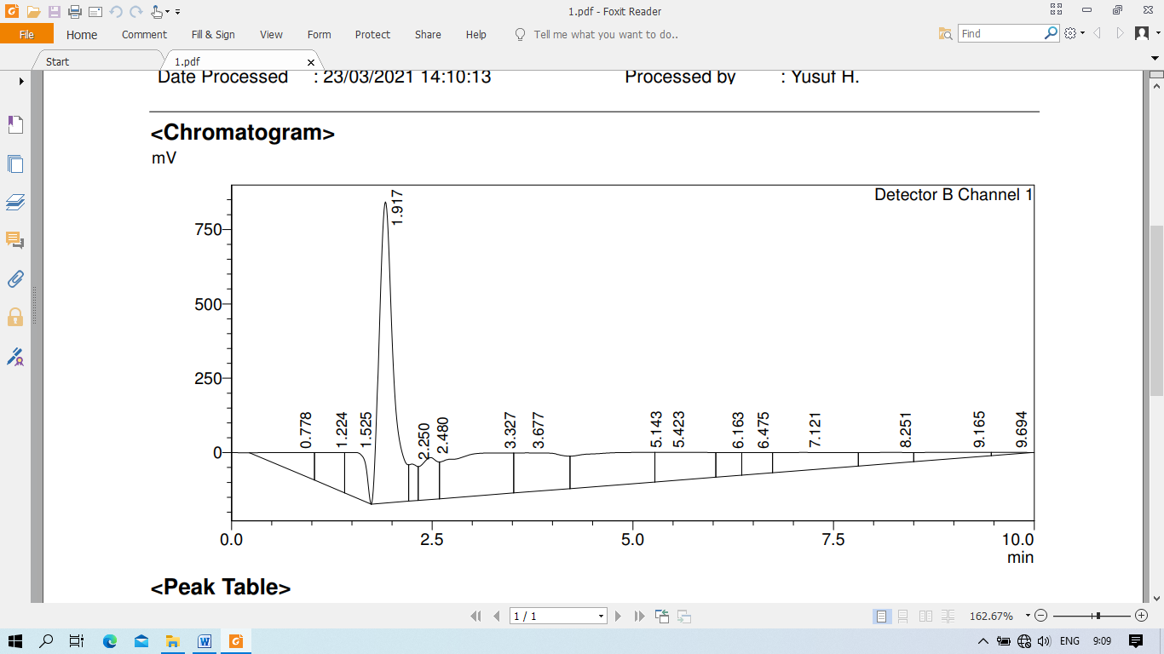

**Figure 3.** HPLC chromatogram on shark cartilage extract.

The HPLC method is a suitable method to determine the presence of glucosamine and chondroitin sulfate compounds in shark cartilage extracts. Separation of analytes using phosphate buffer solution and acetonitrile with a ratio of 99.5: 0.5. The buffer solution pH 3 is a mixture of phosphoric acid solution = 88 ml + 1000 ml aquades + 1.3 grams of potassium dihydrogen phosphate and the flow rate used is 1 ml/minute. In Figure 1 it can be seen that the elution substance has formed a good symmetrical peak.

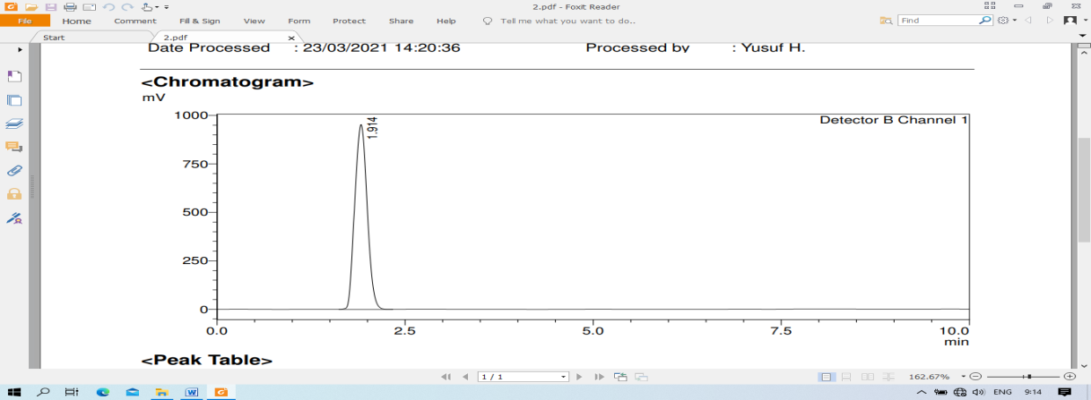

**A**

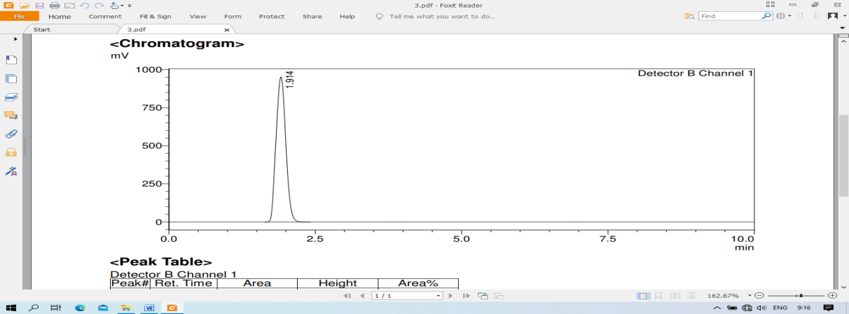

**B**

**Figure 4.** HPLC chromatogram results on Glucosamine (A) and Chondroitin sulfate (B) parameters.

From the HPLC output in the form of a chromatogram (Figure 3), it can be seen that the shark cartilage extract sample (*Carcharhinus sorrah*) has a retention time of 1.917. Meanwhile, the retention time for glucosamine and chondroitin sulfate parameters was 1.914 and 1.914 (Figure 4). This retention time proves that the shark cartilage extract contains glucosamine and chondroitin sulfate compounds.

According to research that has been done by Difficultyowati et al. (2015) stated that in 40 grams of shark cartilage powder it contains 28.36% glucosamine and in 240 grams of shark cartilage powder there is 6.06% chondroitin. Glucosamine, 2-amino-2-deoxy-D-glucose (C6H14NO5) is a monosaccharide having a molecular weight of 197.2 Da (Agiba, 2017; Huskisson, 2008). This compound is the main component of glycosaminoglycans (GAGs) in cartilage and synovial fluid (Sulityowati et al., 2015). Glycosaminoglycans (GAGs) are heteropolysaccharides that have a negatively charged protein at the edge and function as a binder called mucopolysaccharide (Sulityowati et al., 2015). Glucosamine is found in almost all connective tissue, but the most abundant content is in cartilage (Dahmer and Schiller, 2008; Sulityowati *et al*., 2015).

Chondroitin sulfate (CS) is a heteropolysaccharide with long and unbranched chains called glycosaminoglycans with a molecular weight of 50-100 kDa, but after the extraction process the molecular weight becomes 10-40 kDa (Sulityowati et al., 2015; Henrotin et al., 2010) . But according to Huskisson (2008) the molecular weight of chondroitin is 10,000-50,000 Da. CS compounds have the same properties as GC which are hydrophilic, can dissolve in water and produce a liquid that resembles sodium hyaluronate..

**CONCLUSION**

Based on observations that have been made using the High Performance Liquid Chromatography (HPLC) method, it can be concluded that the shark cartilage extract (*Carcharhinus sorrah*) contains glucosamine and chondroitin sulfate compounds with a retention time of 1.917 minutes..

**REFERENCES**

Agiba, A.M. 2017. Nutraceutical Formulations Containing Glucosamine And Chondroitin Sulphate In The Treatment Of Osteoarthritis: Emphasis On Clinical Efficacy And Formulation Challenges. *International Journal of Current Pharmaceutical R esearch* 9 (2): 1-7.

American College of Rheumatology Subcommittee on Osteoarthritis Guidelines. 2000. ACR recommendations for the medical management of osteoarthritis of the hip and knee: 2000 update. *Arthritis Rheum* 43:1905-1915.

Barclay, T.S., Tsourounis, C., and McCart, G.M. 1998. Glucosamine. *The Annals of Pharmacotherapy* 32: 574-579.

Bargahi A and A. Rabbani-Chadegani A. 2008. Angiogenic inhibitor protein fractions derived from shark cartilage. *Journal Biochemical Society* 28 (1): 15–21.

Dahmer, S. & Schiller, R.M. 2008. Glucosamine. *American Family Physician* 78 (4): 471-476.

Dean MN and AP Summers. 2006. Mineralized Cartilage in the skeleton of chondrichthyan fishes. *Zoology* 109 (2): 164-168.

De Mattei, M., Pellati, A., Pasello, M., De Terlizzi, F., Massari, L., Gemmati, D., & Caruso, A. 2002. High doses of glucosamine-HCl have detrimental effects on bovine articular cartilage explants cultured in vitro. *Osteoarthritis and Cartilage* 10 (10): 816–825.

González, R.P., Leyva, A. & Moraes, M.O. 2001. Shark Cartilage as Source of Antiangiogenic Compounds: From Basic to Clinical Research. *Biol. Pharm. Bull*. 24 (10): 1097-1101.

Henrotin, Y., Mathy, M., Sanchez, C., & Lambert, C. 2010. Chondroitin sulfate in the treatment of osteoarthritis: from in vitro studies to clinical recommendations. *Therapeutic Advances in Musculoskeletal Disease* 2 (6): 335-348.

Huskisson, E.C. 2008. Glucosamine and Chondroitin for Osteoarthritis. *The Journal of International Medical Research* 36(6): 1-19.

Hutagalung, E. 2005. Current status of glucosamine and chondroitin therapy in osteoarthritis. *Med J Indones*. 14 (1): 55-58.

Jerosch, J. 2011. Effects of Glucosamine and Chondroitin Sulfate on Cartilage Metabolism in OA: Outlook on Other Nutrient Partners Especially Omega-3 Fatty Acids. *International Journal of Rheumatology*. p:1-17.

Kerri l. Pettrey, ML Cupp, and TS Tracy. 2003. *Dietary Supplements: Toxicology and Clinical Pharmacology*. Edited by: MJ Cupp and TS Tracy © Humana Press Inc., Totowa, New Jersey.

Lippiello, L. 2003. Glucosamine and Chondroitin sulfate: Biological Response Modifiers of Chondrocytes Under Simulated Conditions of Joint Stress. *Osteoarthritis and Cartilage* 11 (5): 335-342.

Lubis, A.M.T., Siagian, C., Wonggokusuma, E., Marsetio, A.F., Setyohadi, B. 2017. Comparison of Glucosamine-Chondroitin Sulfate with and without Methylsulfonylmethane in Grade I-II Knee Osteoarthritis: A Double Blind Randomized Controlled Trial*. Acta Med Indones-Indones J Intern Med* 49 (2): 105-111.

Martel-Pelletier J, A Farran, E Montell, J Verges, JP Pelletier. 2015. Discrepancies in Composition and Biological Effects of Different Formulations of Chondroitin Sulfate. *Molecules* 20 (3): 4277-4289.

Marzuki AS, Kasim dan N Arafah. 2014. Pengaruh Penambahan Natrium Hidroksida Terhadap Waktu Retensi Kadar Kondroitin Sulfat dari Tulang Rawan Ikan Pari (Taeniura lymna). *Jurnal Phinisi* 9 (3): 239-245.

Matsuno, H., Nakamura, H., Katayama, K., Hayashi, S., Kano, S., Yudoh, K., & Kiso, Y. 2009. Effects of an Oral Administration of GlucosamineChondroitin-Quercetin Glucoside on the Synovial Fluid Properties in Patients with Osteoarthritis and Rheumatoid Arthritis. *Bioscience, Biotechnology, and Biochemistry* 73 (2): 288–292.

Miller KL and DO Clegg. 2011. Glucosamine and Chondroitin Sulfate. *Rheumatic Diseases Clinics of North America* 37 (1): 103–118.

Nakano, Ikawa and Ozimek. 2000. An economical method to extract chondroitin sulphatepeptide from bovine nasal cartilage. *Canadian Agricultural Engineering* 42 (4): 205-208.

Pavelká K, Gatterová J, Olejarová M, Machacek, S., Giacovelli, G., Rovati, L.C. 2002. Glucosamine sulfate use and delay of progression of knee osteoarthritis: a 3-year, randomized, placebo-controlled, double-blind study. *Arch Intern Med* 162: 2113 – 2123.

Pelletier, J.M., Farran, A., Montell, E., Vergés, J., and Pelletier, J.P. 2015. Discrepancies in Composition and Biological Effects of Different Formulations of Chondroitin Sulfate. *Molecules* 20: 4277-4289.

Shmagel, A., Demmer, R., Knights, D., Butler, M., Langsetmo, L., Lane, N.E., and Ensrud, K. 2019. The Effects of Glucosamine and Chondroitin Sulfate on Gut Microbial Composition: A Systematic Review of Evidence from Animal and Human Studies. *Nutrients* 11 (2): 1-14.

Siagian C. 2014. Efek Pemberian Kombinasi Glukosamin-Kondroitin Sulfat, Kombinasi Glukosamin-Kondroitin Sulfat-Methylsulfonylmethane, dan Plasebo Terhadap Kesembuhan Pasien Osteoarthritis Sendi Lutut Derajat Kellgren Lawrence I dan II (Uji Klinis Acak Tersamar Ganda). *Tesis*. Jakarta: Universitas Indonesia.

Šimánek, V., Křen, V., Ulrichová, J., Gallo, J. 2005. The Efficacy Of Glucosamine And Chondroitin Sulfate In The Treatment Of Osteoarthritis: Are These Saccharides Drugs Or Nutraceuticals?. *Biomed. Papers* 149(1): 51–56.

Sulityowati, W., Titiek Indhira, A., Arbai, A., and Yatmasari, E. 2015. Glucosamine and Chondroitin Sulphate Content of Shark Cartilage (Prionace glauca ) and its Potential as Anti-Aging Supplements. *International Journal of ChemTech Research* 8 (10): 163-168.

Toffoletto, O., Tavares, A., Casarini, D.E., Redublo, B.M., Ribeiro, A.B. 2005. Pharmacokinetic Profile Of Glucosamine And Chondroitin Sulfate Association In Healthy Male Individuals. *Acta Ortop Bras* 13(5): 235-237.

Václavíková, E., and Kvasnička, F. Isotachophoretic Determination of Glucosamine and Chondroitin Sulphate in Dietary Supplements. *Czech J. Food Sci* 31 (1): 55-65.

Vasiliadis, H.S., Tsikopoulos, K. 2017. Glucosamine and chondroitin for the treatment of Osteoarthritis. *World Journal Orthopedics*  8 (1): 1-11.

Widyaningsih TD, WD Rukmi, E Sofia, SD Wijayanti, N Wijayanti, R Ersalia, N Rochmawati, D Nangin. 2016. Extraction of Glycosaminoglycans Containing Glucosamine and Chondroitin Sulfate from Chicken Claw Cartilage. *Research Journal of Life Science* 3 (3): 181-189.

Xie, J., HY Ye and XF Luo. 2014. An effcient preparation of chondroitin sulfate and collagen peptides from shark cartilage. *International Food Research Journal* 21(3): 1171-1175.