UV (MeOH) spectra of KNA-1 and KNA-2.

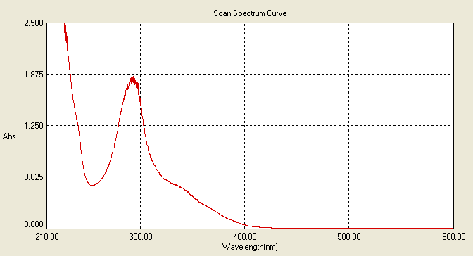

**KNA-1**, λmax = 293 nm

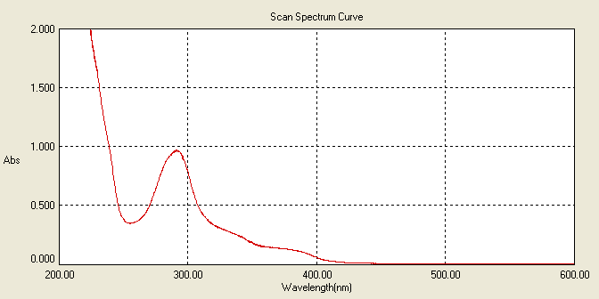

**KNA-2**, λmax = 292 nm

1H NMR (400 MHz, MeOD) spectrum of KNA-1

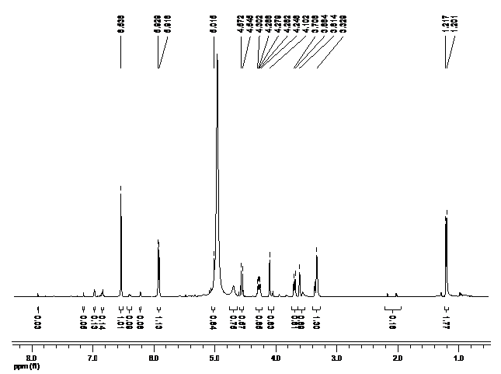

13C NMR (400 MHz, MeOD) spectrum of KNA-1

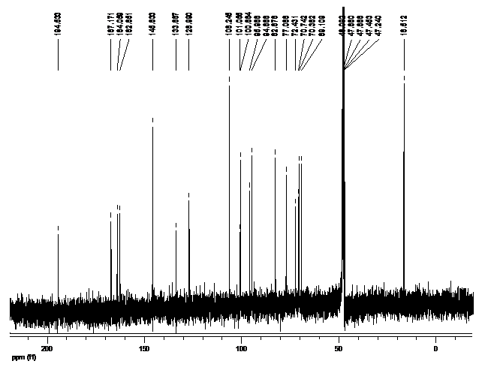

DEPT-135 spectrum of KNA-1

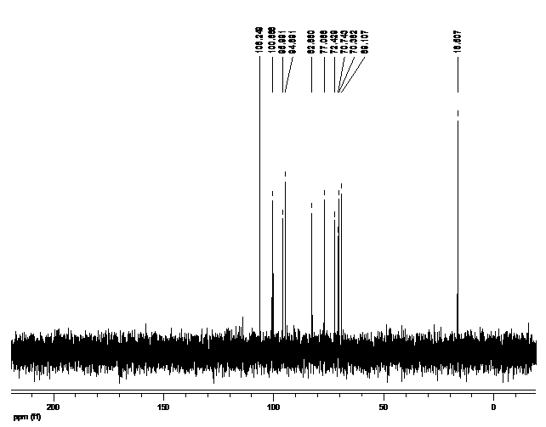

COSY spectrum of KNA-1

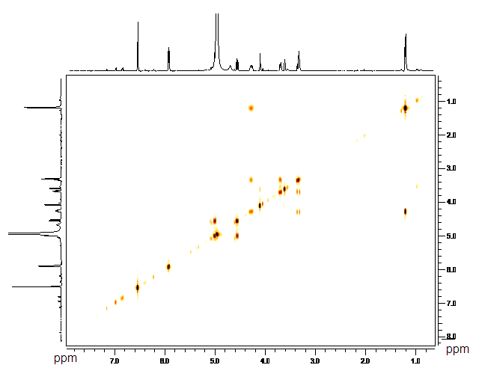

HMQC spectrum of KNA-1

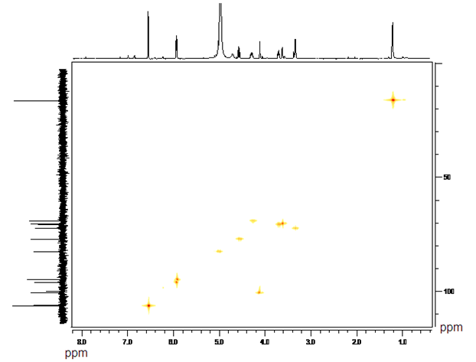

HMBC spectrum of KNA-1

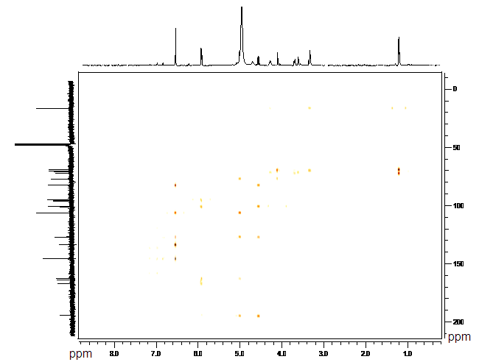

1H NMR (400 MHz, MeOD) spectrum of KNA-2

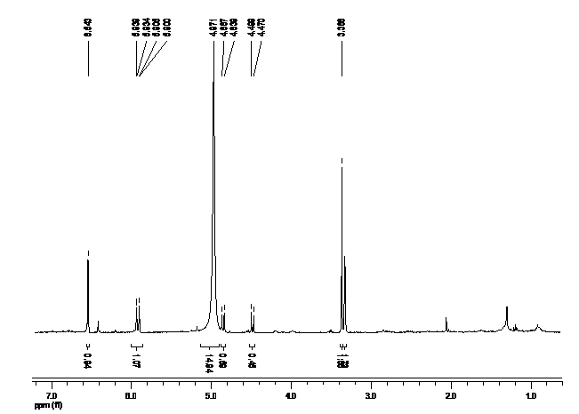

13C NMR (400 MHz, MeOD) spectrum of KNA-2

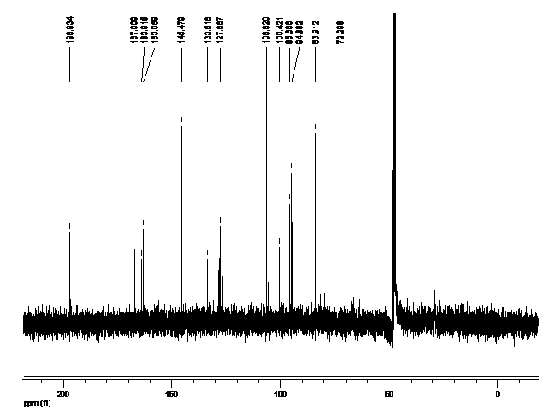

DEPT-135 spectrum of KNA-2

